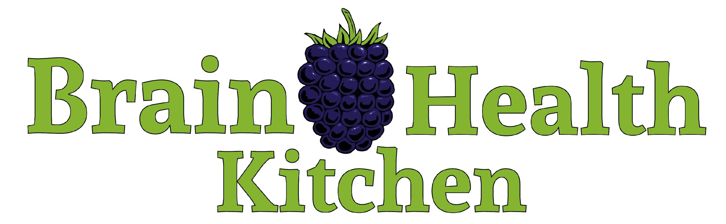
Annie Fenn, M.D.
www.BrainHealthKitchen.com

Brain Health Kitchen Cooking School Goals
Eat more neuroprotective foods. Eat less of the foods known to accelerate cognitive decline. Learn simple techniques to get more brain-friendly foods into each meal. Cook with oils that are not inflammatory to blood vessels and brain. Make the most brain-healthy choices when dining out. Share good-for-your-brain meals with others. Eat a large variety of foods and at least 30 different types of plants each week. Eating should be joyful, satisfying, and delicious, never boring or depriving.

What are Brain-Healthy Foods?
Anti-inflammatory. Nutrient-dense. Low glycemic index. Healthy fats (mono- and polyunsaturated.) Organic if possible. High in fiber. Packed with antioxidants. Colorful.
Low in AGEs (advanced glycation end products.)

10 Brain Healthy Food Groups
- Berries: two or more half-cup servings each week
- Leafy Green Vegetables: six or more servings each week
- Other Vegetables: one or more servings each day
- Whole Grains: three half-cup servings each day
- Nuts: more than five one-ounce servings each week
- Fish and Seafood: at least one serving each week
- Poultry: up to four servings each week
- Beans: more than three half-cup servings each week
- Red Wine: optional; up to one 5-ounce serving per day
- Olive Oil: use as your primary cooking oil

5 Brain Un-Healthy Food Groups
- Red Meat: fewer than three (3 to 5 ounce) servings per week
- Fried Food and Fast Food: less than one serving each week
- Butter: less than one tablespoon per day
- Cheese: enjoy infrequently
- Pastries and Sweets: fewer than five servings per week
Source: Morris et al. MIND diet associated with reduced risk of Alzheimer’s disease. Alzheimers Dement. 2015 Sep;11(9):1007-14.

Brain Healthy Cooking Methods
Slow cook. Slow roast. Braise. Steam. Boil. Grill over indirect heat. Poach. Sauté gently. Sous vide. Marinate meats. Swap olive oil for butter.
Avoid searing, frying, grilling with direct heat. Use only high quality, non-inflammatory cooking oils according to smokepoint.
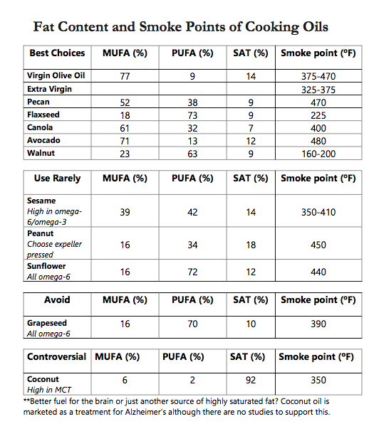
• MUFA=Mono-unsaturated, PUFA=Polyunsaturated • Extra-virgin olive oil (EVOO) is the favored oil of both the Mediterranean and MIND diets. High in polyphenols (such as oleocanthal—a potent anti-inflammatory), vitamin E, hydroxytyrosol (prevents DNA damage and the oxidation of LDL cholesterol), other antioxidants, and monounsaturated fat. • Hydrogenated oils: processed to have more double bonds, more shelf stable, more solid at room temperature. More likely to cause inflammation inside blood vessels leading to deposition of cholesterol and form plaques which lead to heart disease and dementia.

Longevity Foods
The foods common to the five places on earth with the most dementia-free longevity (the Blue Zones.)
Nuts. Beans. 100% whole wheat bread. Fennel. Wakame. Kombu. Shiitake mushrooms. Squash. Avocados. Papayas. Pejivalles. Sweet potatoes. Wild greens. Yams. Black beans. Black-eyed peas. Maize nixtamal. Salmon. Chickpeas. Fava beans. Tomatoes. Brown rice. Barley. Oats. Tofu. Soy milk. Feta. Pecorino cheese. Olive oil. Coffee. Green tea. Red wine. Water. Garlic. Mediterranean herbs. Turmeric. Honey. Milk thistle.
Longevity Practices
95/5 plant-based (95% plants/5% animal products). Retreat from meat.Take or leave fish. Diminish dairy. Daily dose of beans. Slash sugar. Snack on nuts. Sour on bread. Go wholly whole. Drink mostly water. Find your tribe. Wine@5.

Source: Blue Zones data, Dan Buettner, National Geographic Society.
Additional references: Available upon request.

KEEP IN TOUCH!

Annie Fenn, MD
Brain Health Kitchen
Cooking School
Online Community
Email: brainhealthkitchen@gmail.com
Website: www.BrainHealthKitchen.com
Instagram: @brainhealthkitchen
Facebook: @Brain Health Kitchen
Twitter: @AnnieFennMD
Mailing: POB 1328, Wilson, WY 83014

For inquiries about private cooking class, speaking engagements, and upcoming events, contact
brainhealthkitchen@gmail.com

To sign up for free monthly newsletter of recipes and brain health news,
go to www.BrainHealthKitchen.com

Let’s not get Alzheimer’s, ok?

